Probability Theory:

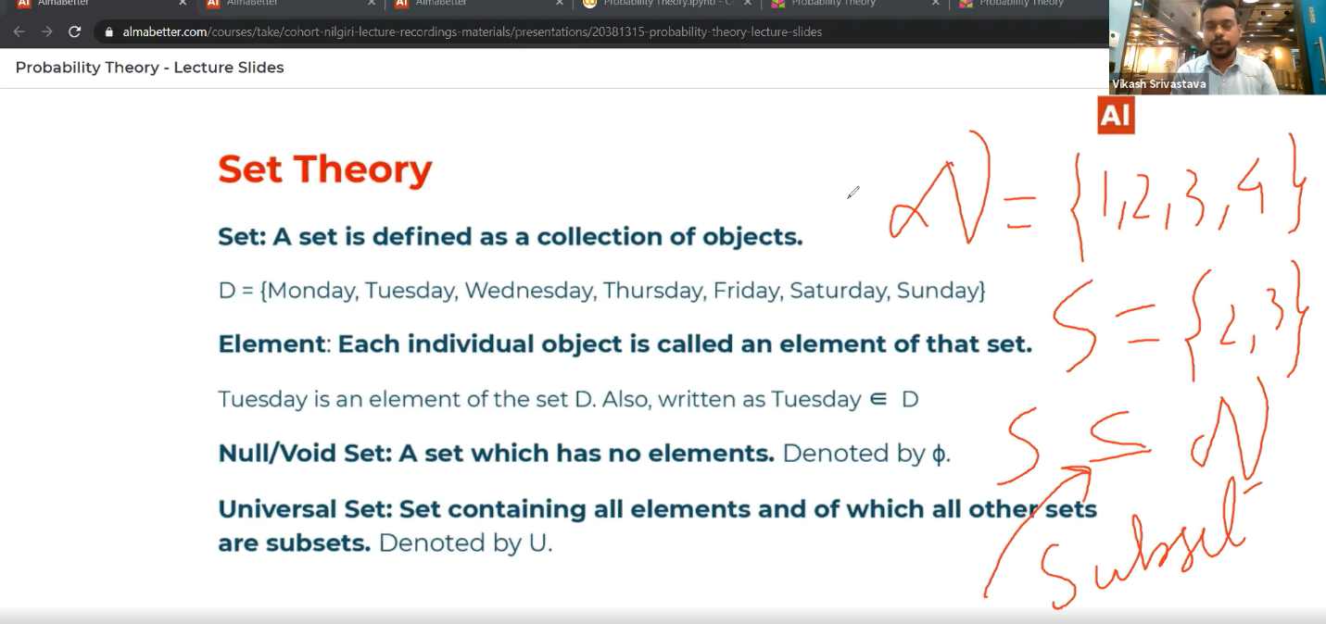Introduction to Set:

# Intersection, Union, Complement:

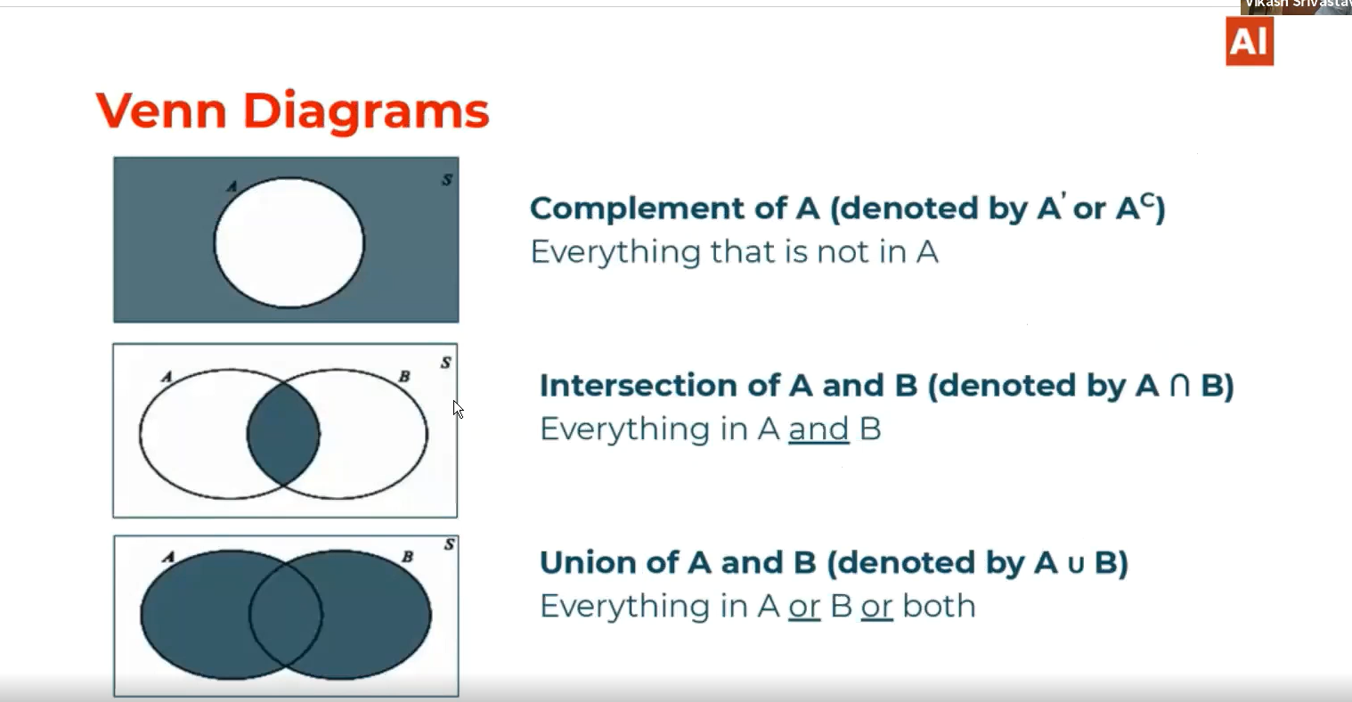

# Visualization of A intersection C’ :

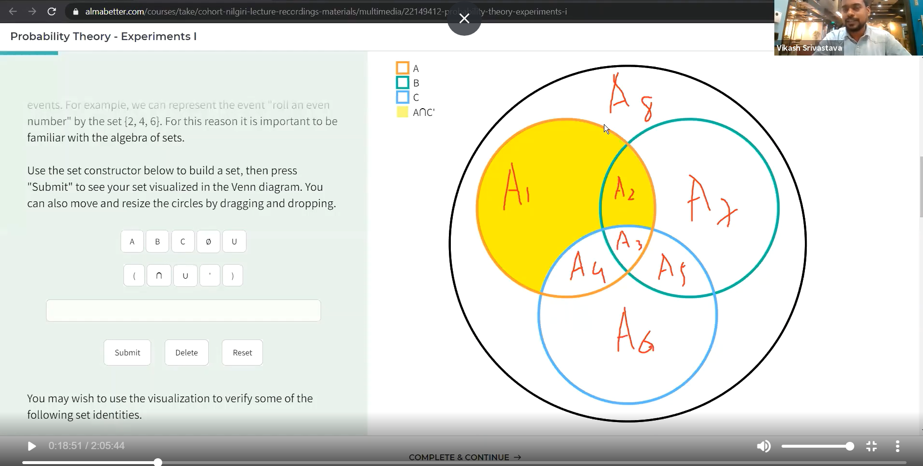

B’ intersection C’:

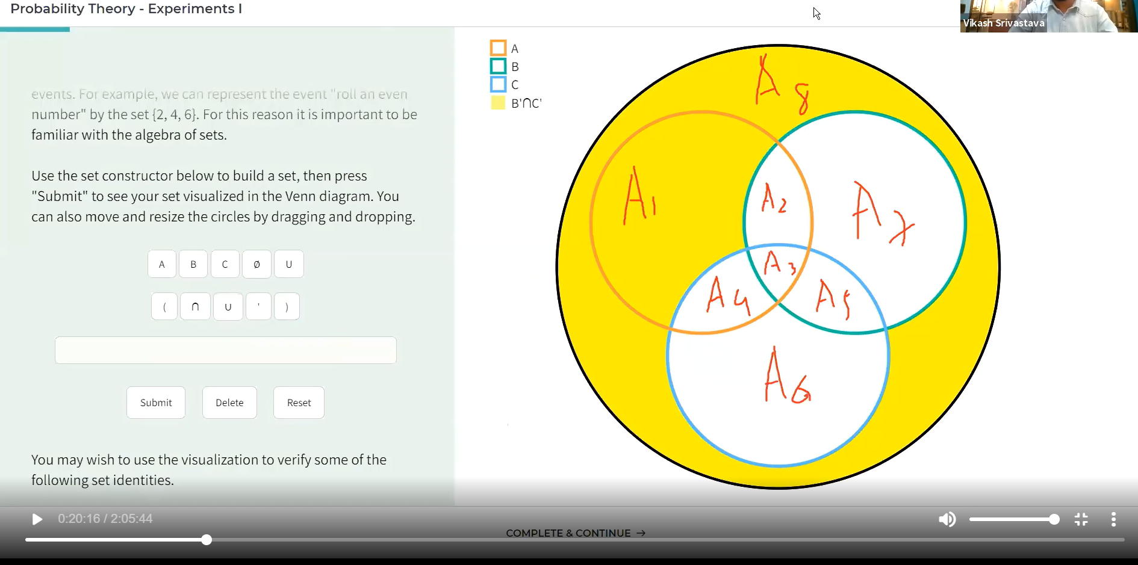

# A’ union C:

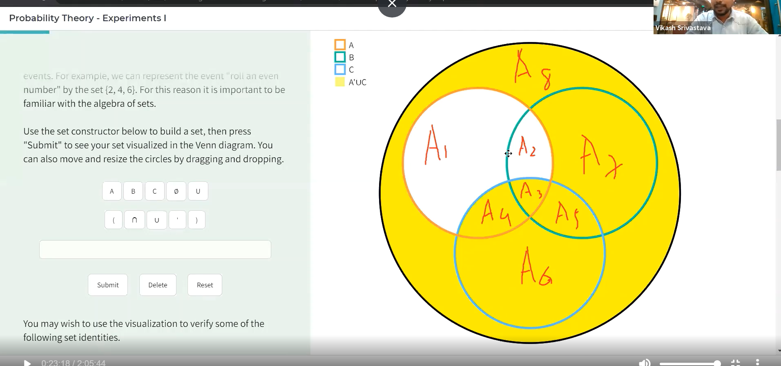

B union Empty/null set:

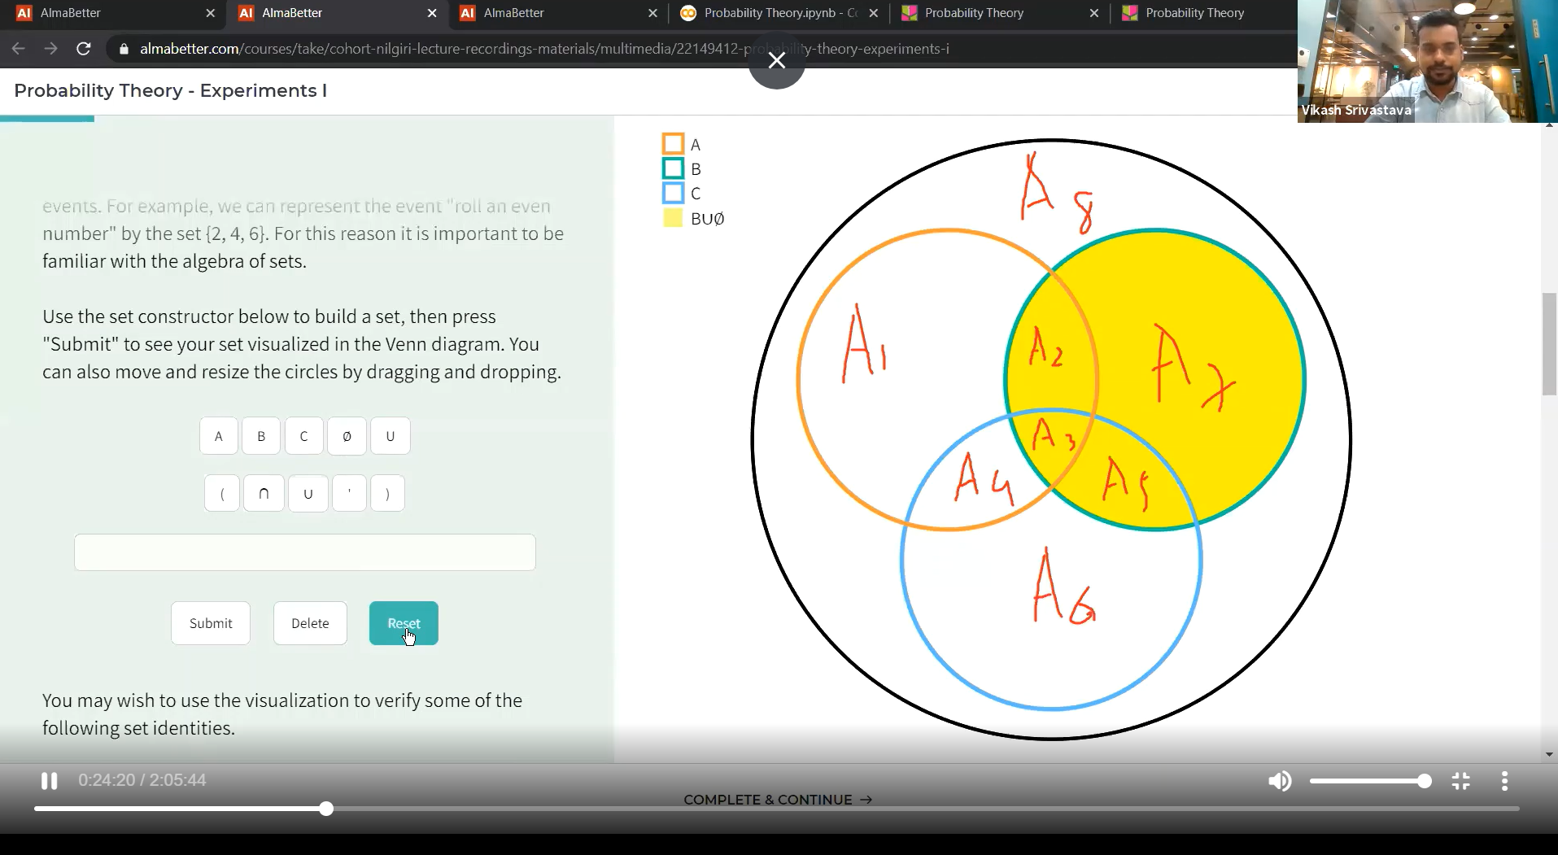

# C intersection null set:

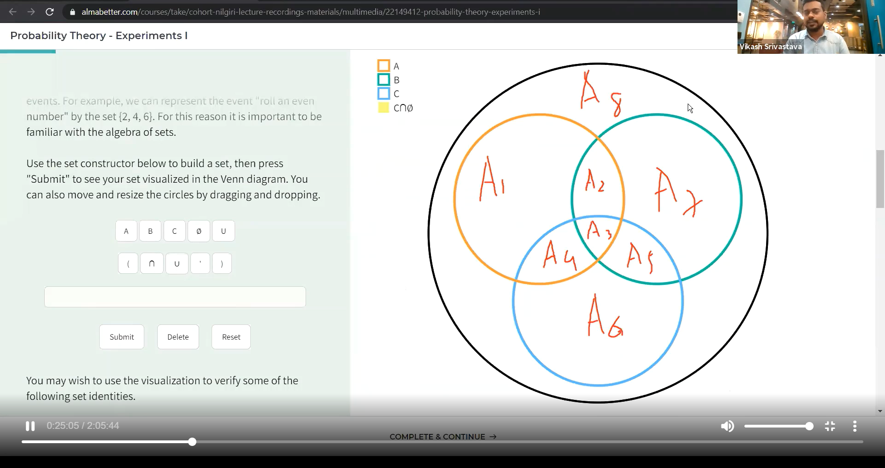

(A union B) intersection (A union C)

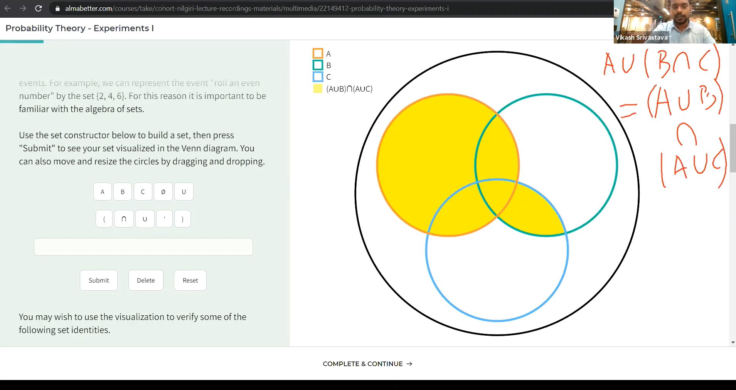

# Demorgans law:

(A union B)’ == A’ intersection B’

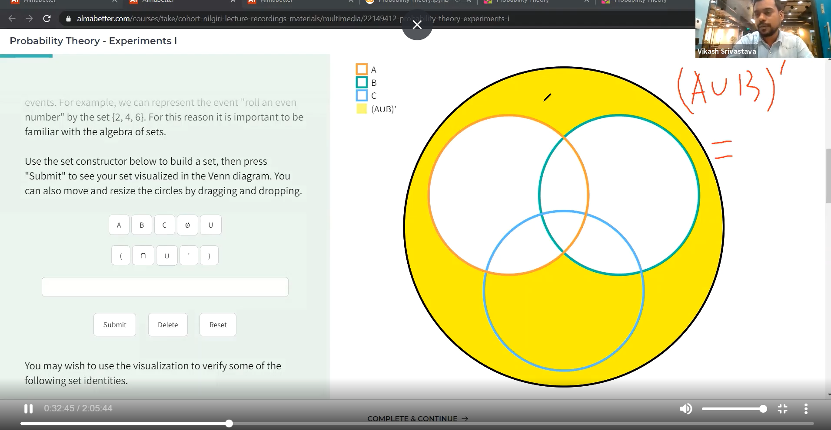

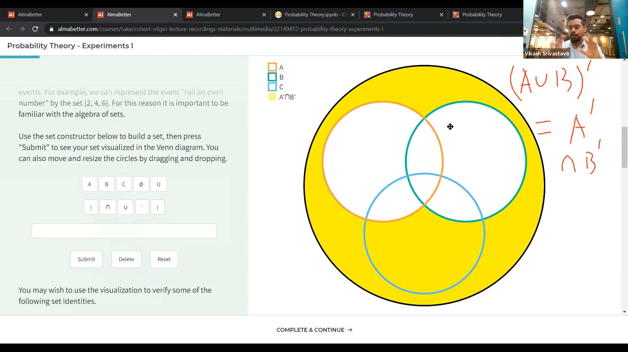

# Mutually Exclusive:

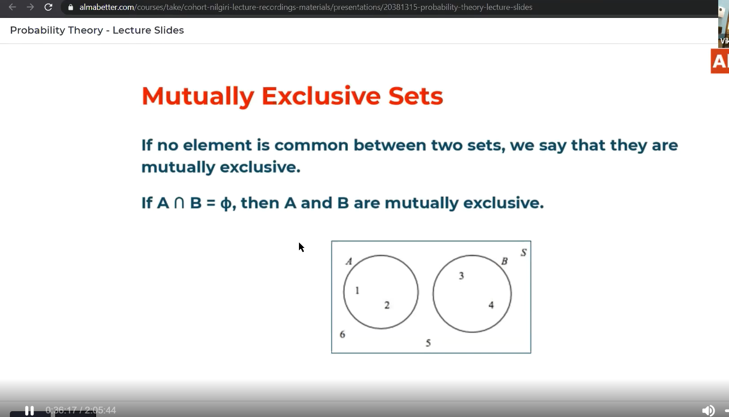

# Permutation:

Permutation is used where the sequence of number or alphabets matters.(ex:Dictionary).

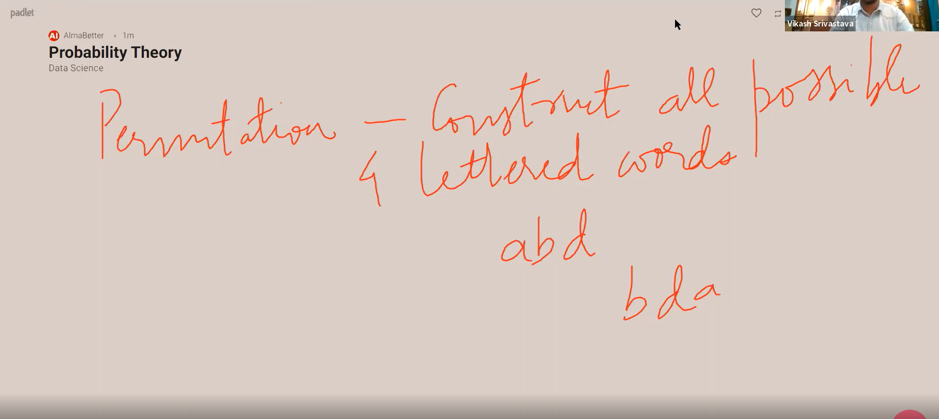

# Combination:

Here the sequence of elements doesn’t matter.

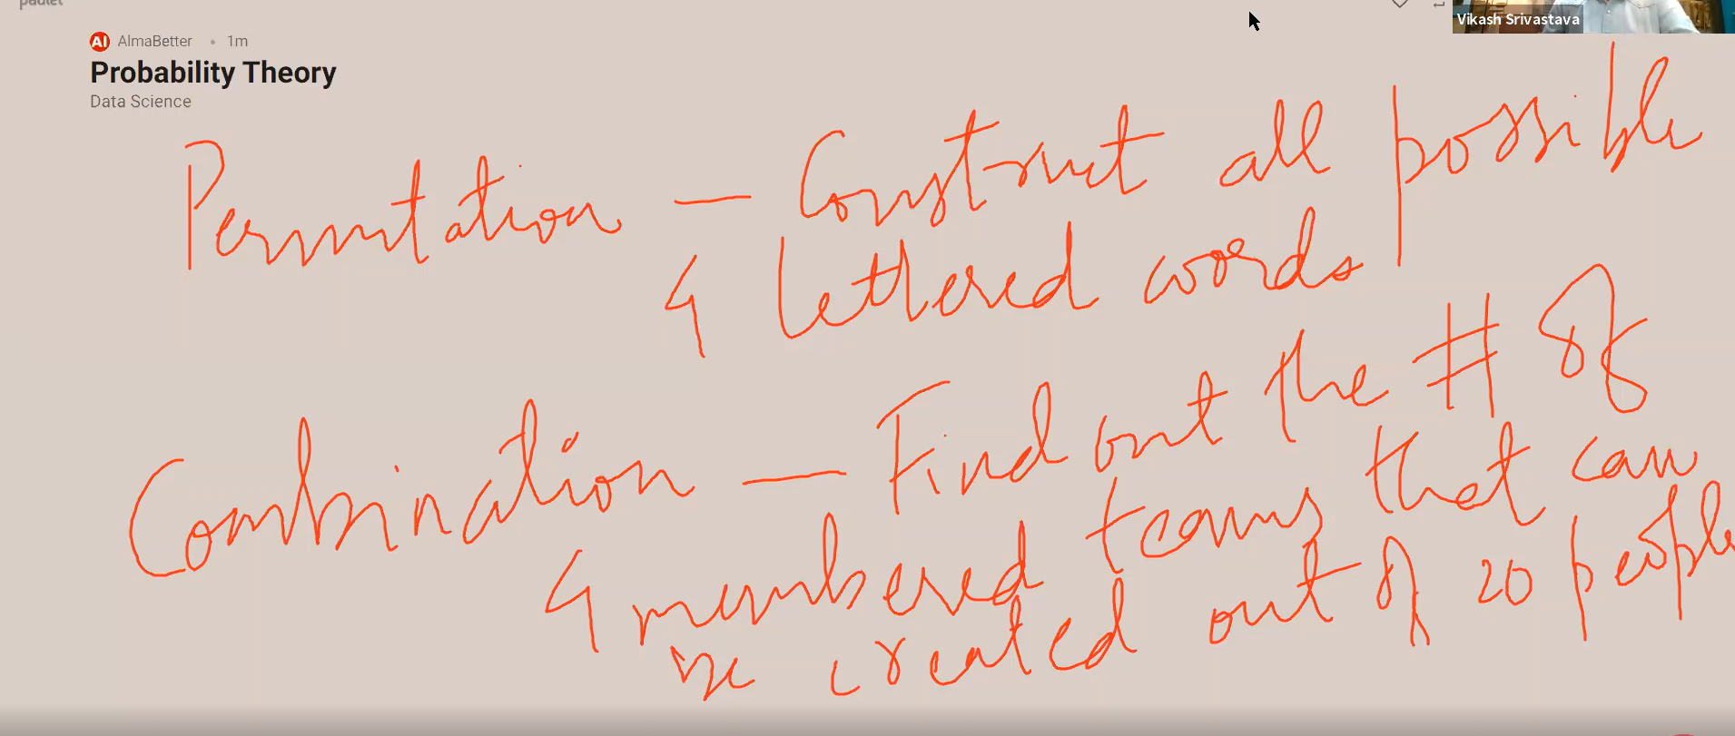

# Difference between permutation and combination:

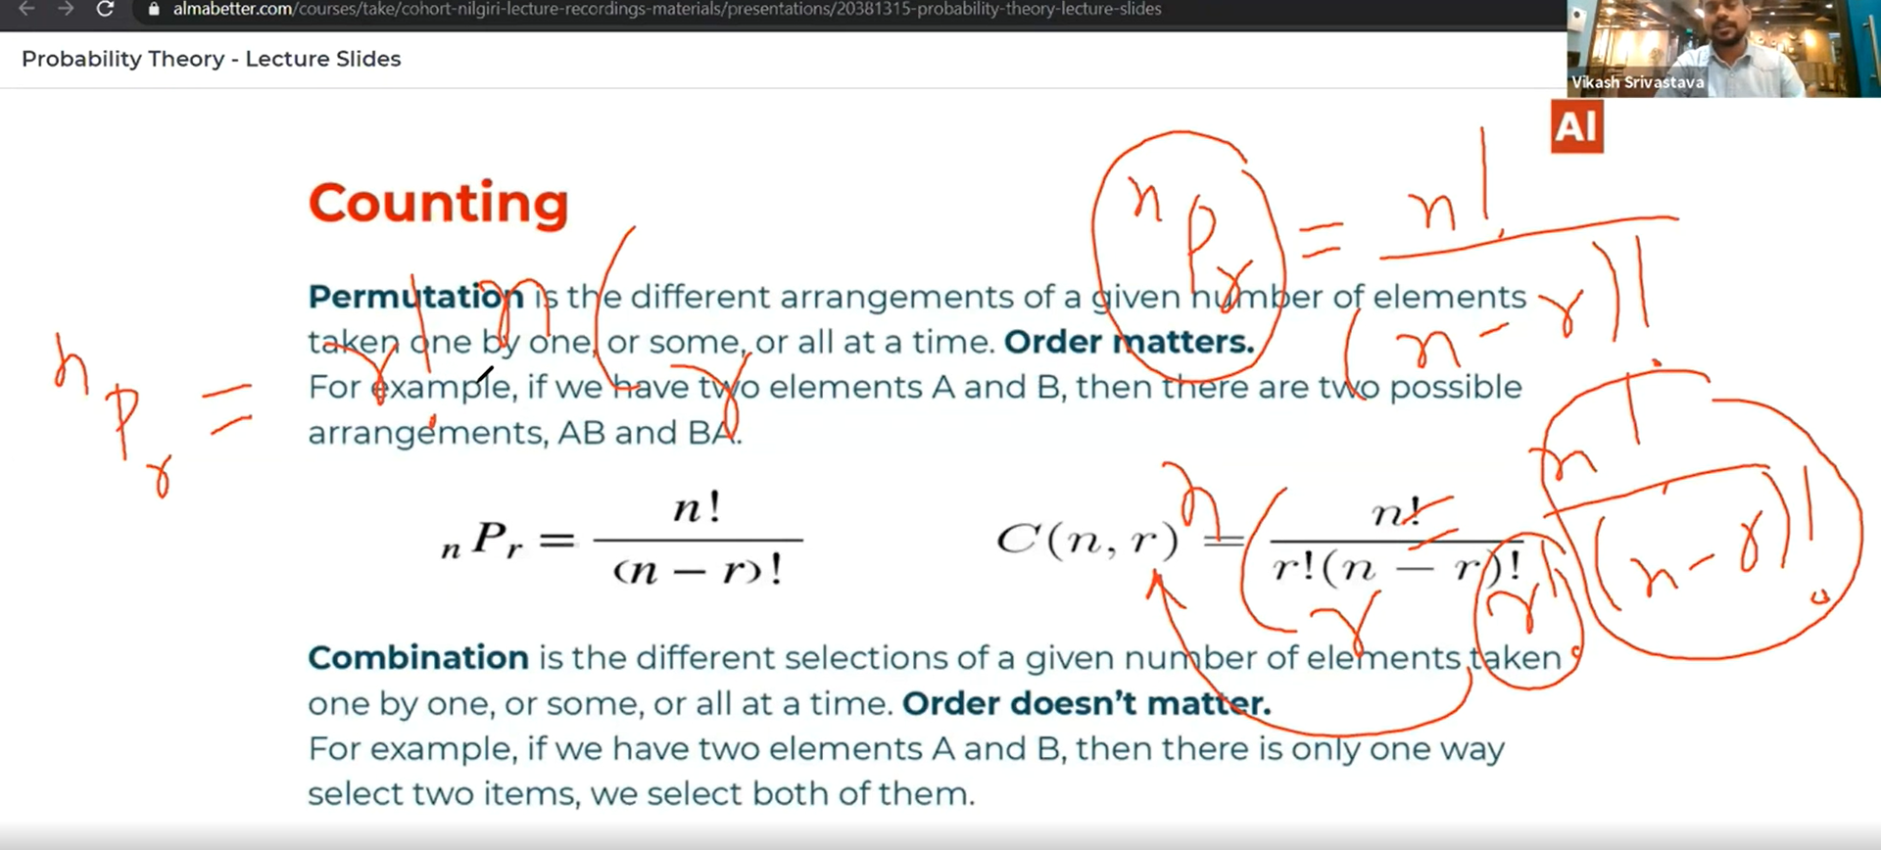

# Permutation of selecting 2 marbles out of 3 marbles:

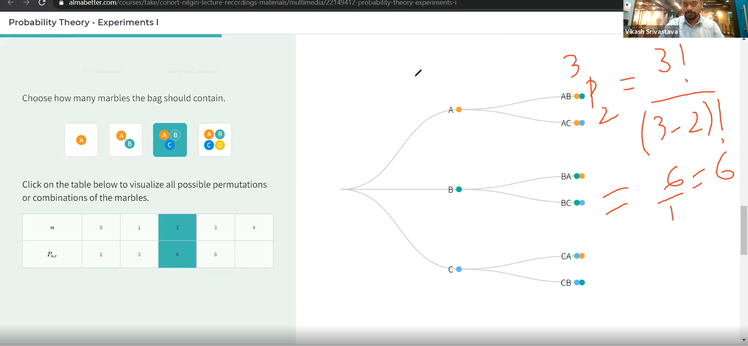

# Without replacement picking marbles permutation:

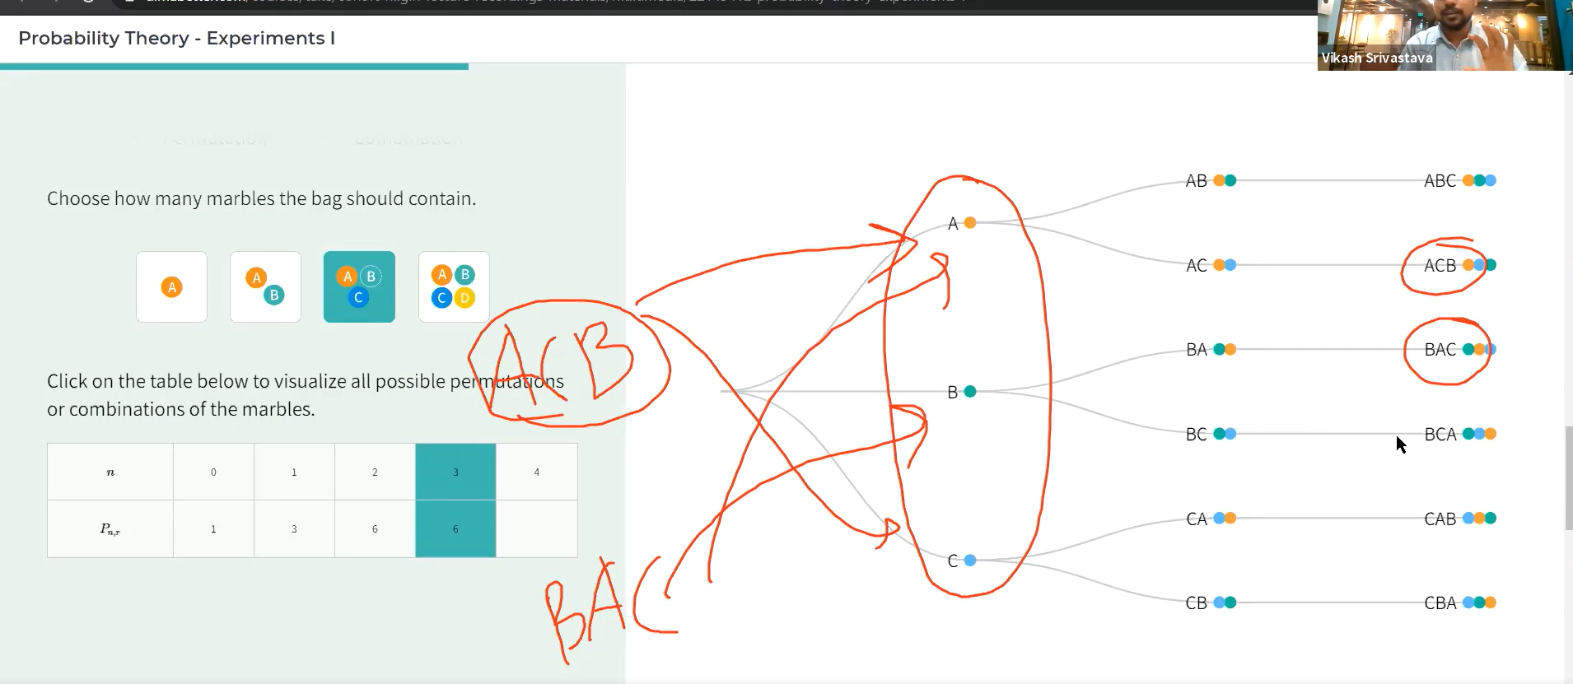

# Combination:

Here the sequence doesn’t matter.

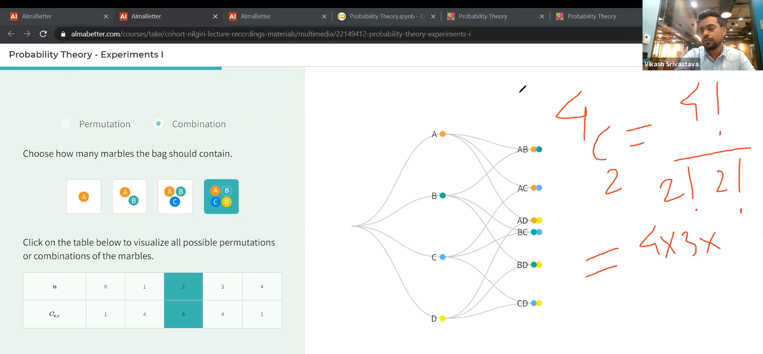

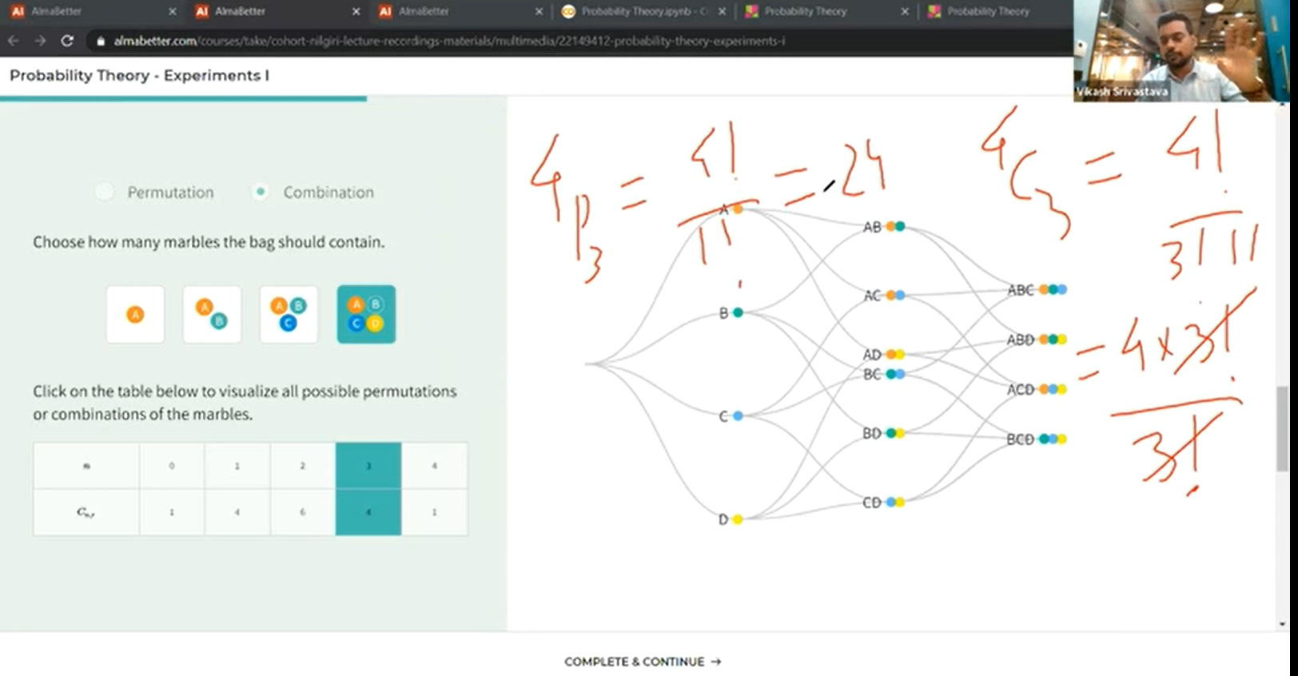

Probability: